EXERCISE 1-**Control Structures**

**Table creation:**

CREATE TABLE Customers (

    CustomerID NUMBER PRIMARY KEY,

    Name VARCHAR2(100),

    DOB DATE,

    Balance NUMBER,

    LastModified DATE

);

CREATE TABLE Loans (

    LoanID NUMBER PRIMARY KEY,

    CustomerID NUMBER,

    LoanAmount NUMBER,

    InterestRate NUMBER,

    StartDate DATE,

    EndDate DATE,

    FOREIGN KEY (CustomerID) REFERENCES Customers(CustomerID)

);

**INSERT SAMPLE DATA:**

INSERT INTO Customers (CustomerID, Name, DOB, Balance, LastModified)

VALUES (1, 'John Doe', TO_DATE('1950-05-15', 'YYYY-MM-DD'), 15000, SYSDATE);

INSERT INTO Customers (CustomerID, Name, DOB, Balance, LastModified)

VALUES (2, 'Jane Smith', TO_DATE('1985-07-20', 'YYYY-MM-DD'), 8000, SYSDATE);

INSERT INTO Loans (LoanID, CustomerID, LoanAmount, InterestRate, StartDate, EndDate)

VALUES (1, 1, 5000, 5, SYSDATE, SYSDATE + 20);

INSERT INTO Loans (LoanID, CustomerID, LoanAmount, InterestRate, StartDate, EndDate)

VALUES (2, 2, 10000, 6, SYSDATE, SYSDATE + 365);

COMMIT;

**ADDING isVIP column:**

ALTER TABLE Customers ADD IsVIP VARCHAR2(5);

**ENABLING OUTPUT:**

SET SERVEROUTPUT ON;

**SCENARIO 1:apply 1% interest discount for customers over 60**

BEGIN

    FOR rec IN (

        SELECT l.LoanID, l.InterestRate, c.DOB

        FROM Loans l

        JOIN Customers c ON l.CustomerID = c.CustomerID

    )

    LOOP

        IF MONTHS_BETWEEN(SYSDATE, rec.DOB)/12 > 60 THEN

            UPDATE Loans

            SET InterestRate = InterestRate - 1

            WHERE LoanID = rec.LoanID;

        END IF;

    END LOOP;

    COMMIT;

END;

/

SELECT * FROM Loans;

**OUTPUT:**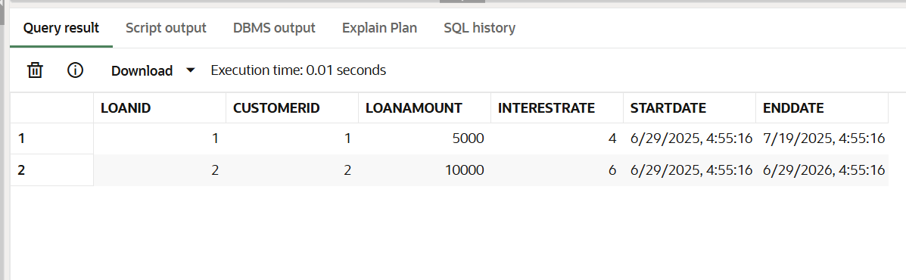

**SCENARIO 2:** S**et VIP status for high-balance customers**

BEGIN

    FOR rec IN (

        SELECT CustomerID, Balance

        FROM Customers

    )

    LOOP

        IF rec.Balance > 10000 THEN

            UPDATE Customers

            SET IsVIP = 'TRUE'

            WHERE CustomerID = rec.CustomerID;

        END IF;

    END LOOP;

    COMMIT;

END;

/

SELECT CustomerID, Name, IsVIP FROM Customers;

**OUTPUT:**

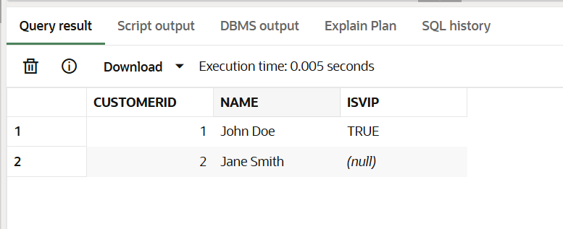

**SCENARIO 3:** **Send loan due reminders within 30 days**

BEGIN

    FOR rec IN (

        SELECT l.LoanID, l.EndDate, c.Name

        FROM Loans l

        JOIN Customers c ON l.CustomerID = c.CustomerID

        WHERE l.EndDate BETWEEN SYSDATE AND SYSDATE + 30

    )

    LOOP

        DBMS_OUTPUT.PUT_LINE(

            'Reminder: Dear ' || rec.Name ||

            ', your loan with ID ' || rec.LoanID ||

            ' is due on ' || TO_CHAR(rec.EndDate, 'DD-MON-YYYY')

        );

    END LOOP;

END;

/

**OUTPUT:**

